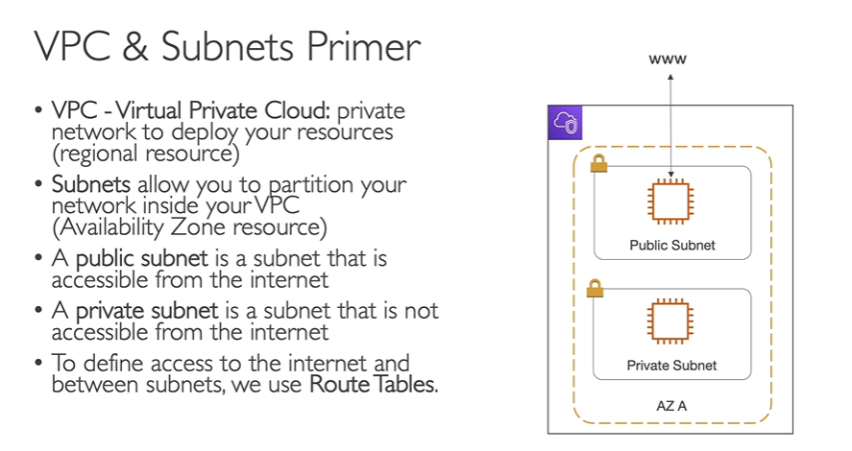

Databases can fall under Private Subnets as they don’t need to be exposed to the internet.

Load balancers can be under Public Subnet as they should be publicly accessible.

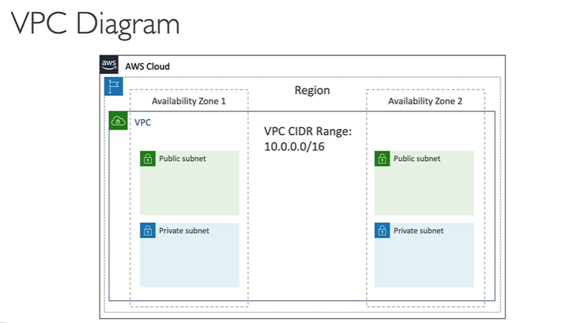

In the above example, we have 2 AZs, 1 VPC, 4 subnets, 2 of them are public and 2 are private.

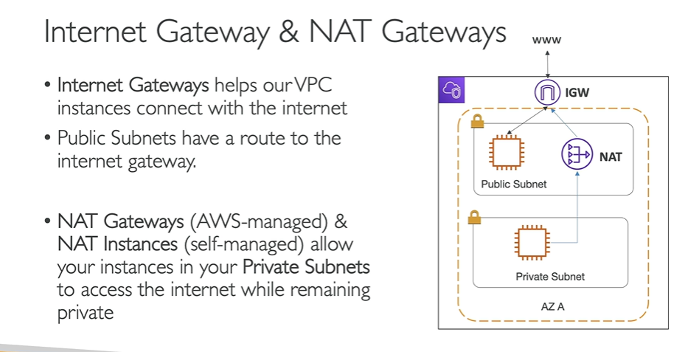

**Cidr.xyz**

A VPC can have only one internet gateway.